Product Main Parameter/Function
Camera | Description
Chip | CV1821
Sensor | SC3335/GC4653/SC401AI/OV4689/SC4336
Resolution | 2304x1296P、2560x1440P
Diagonal angle of view | 106°
Lens focal length | 4mm,6mm
Night vision function | Infrared night vision ,Color night vision
AV | Description
Video coding protocol | H.264/H.265
Video code rate | 80Kbps~1Mbps(self-adaption)
Audio compression method | G.711A/AAC
Function | Description
3D digital noise reduction | Support
Wide dynamic | Support
Backlight compensation | Support
White balance | Support
Human shape detection | Support
Motion detection | Support
Voice detection | Support
Cloud broadcasting | Support
Aural-visual alarm | Support
Network | Description
Network Protocol | L2TP, IPv4, IGMP, ICMP, ARP, TCP, UDP, DHCP,RTP,RTSP,  RTCP,UPnP, DNS,PPPoE,DDNS,NTP, FTP,HTTP, HTTPS,SIP,  802.1x
Interface | Description
Audio input and output | Audio wiring, 1 wires input, 2 wires output
Power supply | 12V⎓1A,PoE 48V⎓0.3A
Button | Reset button
Network interface | RJ45 10M/100M
Storage | Description
Local storage | Micro SD, support a maximum of 128GB
Operation | Description
Working environment | -20℃ to +60℃

CV1821+SC3335/GC4653/SC401AI/OV4689/SC4336
Wiring diagram
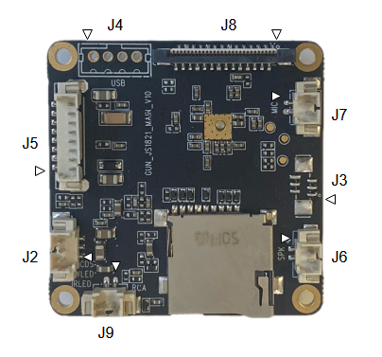
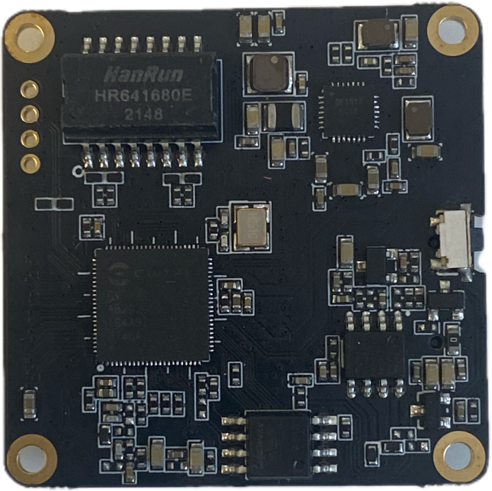

Interface | Description
J4 | 1:12V_IN 2:USB_DP 3:USB_DM 4:GND
J8 | 1:VCC3.3 2:VCC1.8 3:VCC1.2 4:SEN_PWDN 5:CAM_RST 6:CAM_I2C_SCL  7:CAM_I2C_SDA 8:GND 9:CAM_MCLK 10:GND 11:CAM_RX_0N 12:CAM_RX_0P  13:GND 14:CAM_RX_1N 15:CAM_RX_1P 16:GND 17:CAM_RX_2N  18:CAM_RX_2P 19:GND 20:CAM_RX_3N 21:CAM_RX_3P 22:GND  23:CAM_RX_4N 24:CAM_RX_4P 25:GND 26:IR_CUT_P 27:IR_CUT_N  28:IRC_PWR
J7 | 1:MIC_IN 2:GND
J3 | 1:GPIO1 2:GPIO2 3:GPIO3 4:GPIO4 5:GPIO5 6:GND
J6 | 1:SPK- 2:SPK+
J9 | 1:RCA_OUT 2:GND
J2 | 1:IRLED 2:WLED 3:CDS
J5 | 1:12V_IN 2:GND 3:ETH_RX- 4:ETH_RX+ 5:ETH_TX-  6:ETH_TX+ 7:PHY_LED 8:KEY

